## **Methodology**

The project will be developed using agile methodology. Unlike traditional methodologies, agile methodology divides a project into different phases and uses an iterative and incremental approach to complete them along with constant customer collaboration and continuous improvements at every iteration. The sequence of project phases like analysis, design, development, testing, and deployment in an iterative way rather than a linear way is the main difference between agile and traditional software development methodology. Scrum framework is mostly used agile approach in software development and it will be used in this project. In Scrum methodology, requirements are divided into user stories and all the user stories are assigned to the product backlog in the storyboard. Then the higher priority user stories are brought into the sprint backlog in the sprint planning before starting a sprint. A sprint last 2 to 4 weeks. From analysis to deployment, all phases are done in a sprint. The amount of user stories that are brought to the sprint backlog depends on the velocity of the developers. In the end, the completed works are moved to the Done section in the storyboard to review them. If there is any task left to be completed or requires some modification then it will be completed in the next sprint. Then user stories are again brought to the sprint backlog for the next sprint in the sprint planning. The sprint repeats until all the user stories are completed (Team, 2018).

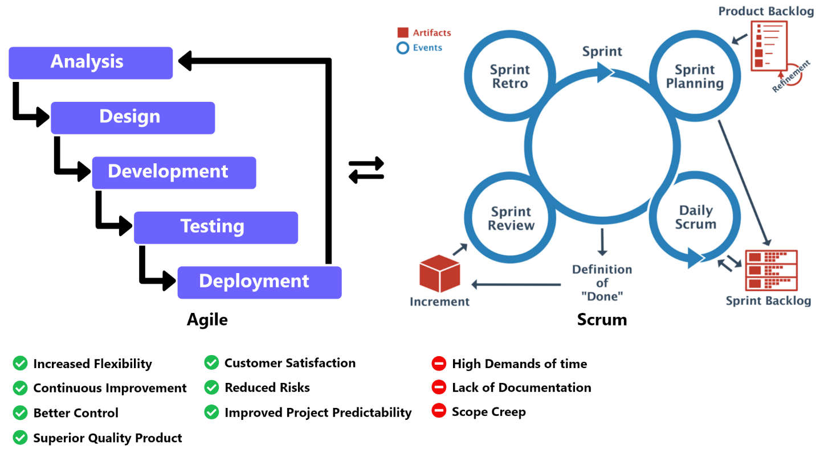

Figure 1: Agile with Scrum methodology

In traditional methodology, Limited customer involvement results into poor customer satisfaction, documentation consumes more time rather than spending time in product deliver, and requirements changing and modification is not accepted. This all results into low quality product (Team, 2018). Agile continuous delivery, continuous improvement, and continuous collaboration over every iteration increases flexibility and improves project predictability. One can have better control of the project due to which project risks are also highly minimized. Customer collaboration increases customer satisfaction. Continuous improvement and customer satisfaction increases product quality in a high rate (Kissflow, 2021). Agile methodology also has some downsides like lack of documentation, continuous collaboration is difficult to maintain, lack of processes easily sidetracks teams, and does not match with long term process like building a house that has a fixed delivery (Wrike, 2022).

## **Tools**

The project will be designed and developed using Android Studio, Visual Studio Code, and MongoDB Compass. Help will be taken from Google Chrome/Firefox. MS Word, Adobe XD, and Team Gantt will be used for documentation.

## **Technology**

Flutter along with Dart programming language is the major technology that will be used in this project.